# Title: Head-Controlled Arduino Vehicle

**Interim report**

Name: Marcel Troscianko

Matric No: 40173086

Introduction

The idea is inspired by the recent rise of Virtual Reality and motion controllers – a head-mounted toy car controller. It would be a helmet or goggle mounted sensing system that detects the user’s movements and translates those into commands for a little car with a camera, such that the camera moves in-sync with the user’s head. The basic prototype will relay the video from the camera to the mobile app, while the full product would include two cameras linked to a VR headset so that the user can see what the drone sees along with full 3D perspective.

### Deliverables

* Controllable wheeled vehicle (little toy)
* Headset with sensors
* Mobile app

The report won’t go extremely in-depth as I already had to cut out a couple of pages worth of basic information to keep within the three-page limit.

Current status

Having been waiting for payment to buy an Arduino kit for use at home and dealing with a low group size issues for our Group Project I haven’t been able to create a physical device just yet but I have been able to create a Bluetooth-enabled mobile app in Android Studio to test and eventually calibrate the android devices. I have also been able to select devices online for purchase when my money comes in. The hardware is listed below:

|  |  |  |
| --- | --- | --- |
| IMU | MPU-9250 | I decided I’ll need to go for both an accelerometer and a gyroscope to control the device. I’ll need two of them (one for headset, one for vehicle) and a magnetometer could come in handy if it turns out the accelerometer and gyroscope calibrations drift over time. I went for a breakout one because one of them must be mounted on the headset which must be as small as possible. |
| Motors | <Undetermined> | I haven’t yet decided on the motors to use, but they’ll need to be 3V-9V |
| Vehicle Controller | Arduino Uno | It’s the type we’ve used at university and therefore the one I’m most comfortable using |
| Headset Controller | Arduino Micro | This is the easiest to use micro-sized Arduino and has a near-identical pin layout to the Uno |
| Bluetooth Device* | Bluetooth HC-05 | This is a commonly used Bluetooth device so it has multiple online tutorials.  *NOTE: May change to WiFi module if distance is too short. |
| H-Bridge | H-Bridge Motor Driver 1A - SN754410 | Recommended on tutorials I’ve looked into |

These will be used to create devices shown in the diagrams below.

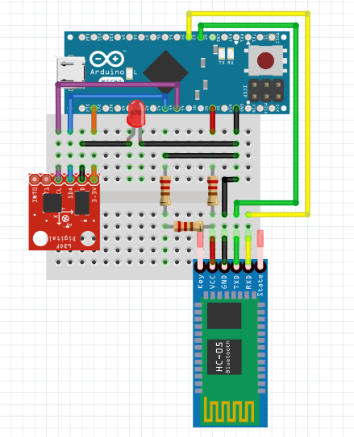 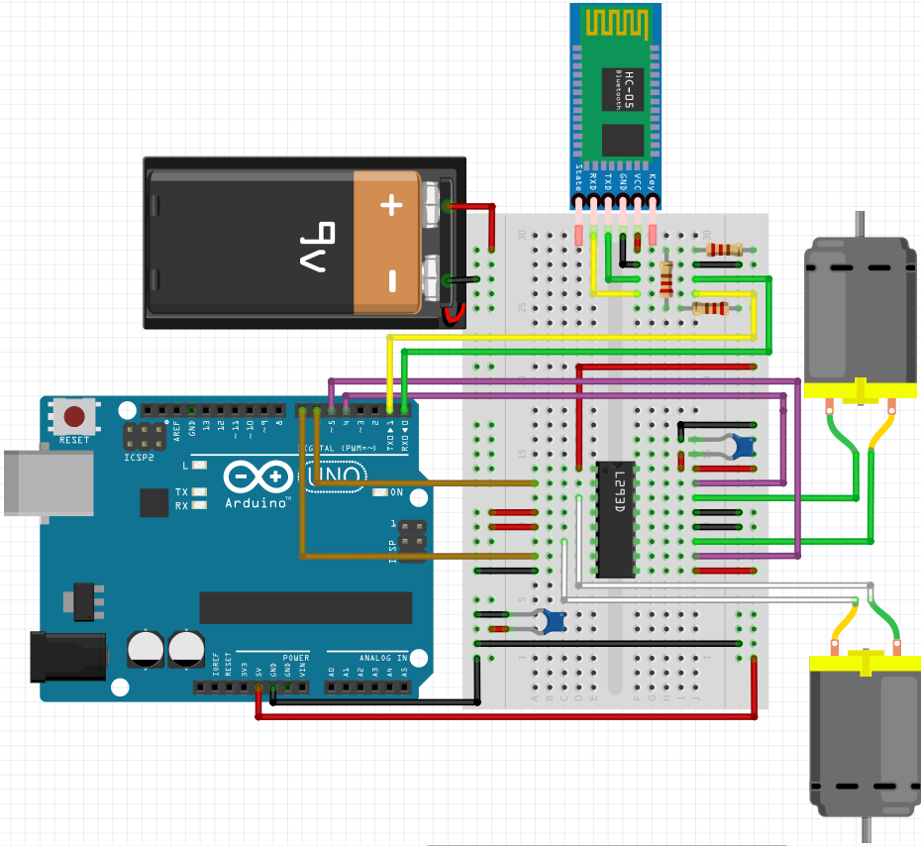

The diagram on the left represents the headset device which has been made as small as possible. The diagram on the right represents the vehicular device. It’s not very small but it has no reason to be so that’s not a problem. It shows a 9V battery but that’s not correct – this is the only battery of that type that the diagramming tool I used allowed for. I haven’t been able to find a camera I’m happy with and due to the amount of work in my other two modules I haven’t been able to look at the coding side of camera usage, so I decided to leave that aspect of the project until I have a functioning vehicle.

Looking into drone development for extra hints I found that an IMU which includes a magnetometer could be used to see the device’s alignment with the planet’s magnetic field. This could actually be useful if I put one a 9 Degrees of Freedom IMU on the headset device and a regular magnetometer on the vehicle, because this would allow the vehicle to align itself with the controller-headset at the beginning of operation and check for alignment every few seconds to fix desyncronisation issues. The precision of this hasn’t been confirmed yet though so I’m not including it in the diagrams or description.

Next comes the Android application. This is where most of the time went into thus far to work with Bluetooth, though not much of it could be tested outside of the practical sessions. When tested, however, it’s shown to be working with regular Bluetooth but ***not*** Bluetooth Low Energy modules – they seem to use a different protocol entirely. Below is a set of screenshots of the application inside Android Studio.

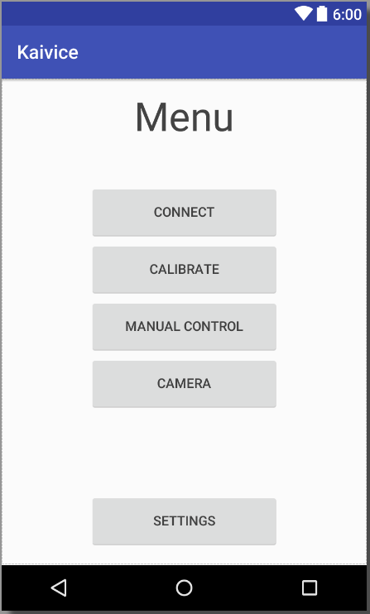 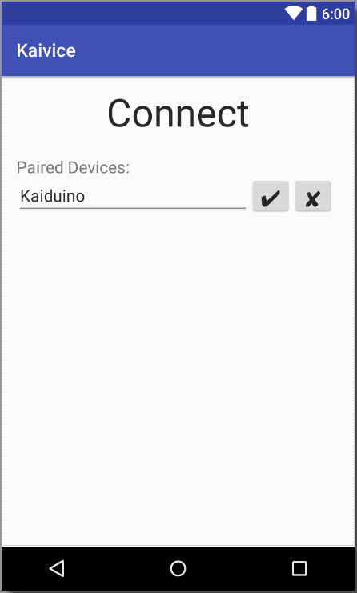 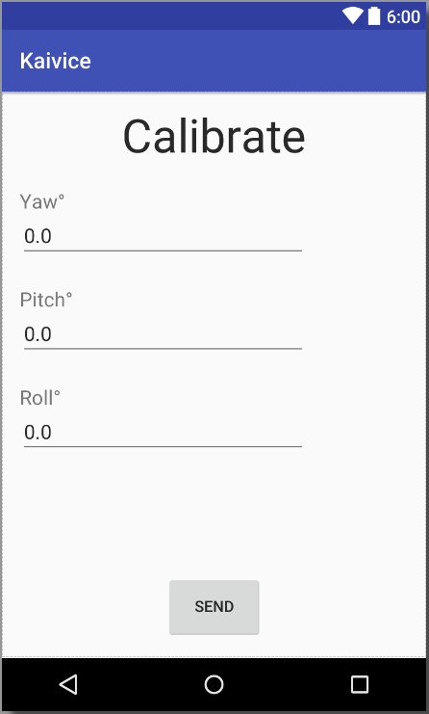 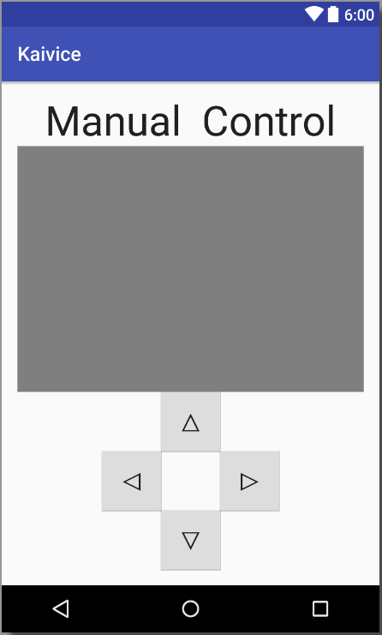 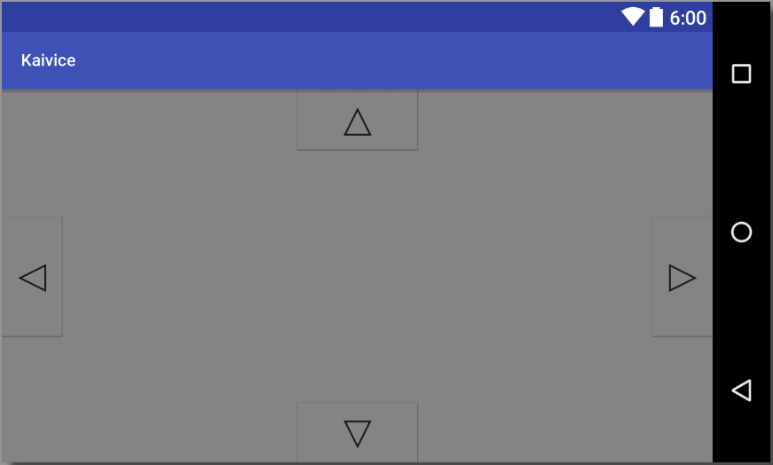

NOTE: The grey fields are buffered video players (Video Views) used for the camera.

The project is a little behind schedule due to problems with other modules, but is still fully expected to be finished way before the hand in date. Below is the original schedule presented in the Initial Project Proposal:



Future programme of work

The device has not yet been built, but the parts will be purchased soon so building will be the first task – this shouldn’t be an issue as the device has already been designed and should function correctly once wired up. The device won’t initially use any soldering as there may be issues in design, the modules must be soldered have also been bought in a breadboard-usable format.

A camera module will be incorporated into the design and connected to the Android app, though I’ve made the choice that will have to wait until the tests prove the device works so as not to push too far without being certain the project will succeed.

Issues and concerns

There first problem that might occur would be testable within the next week – Bluetooth may prove to be too weak a transmitter for all the information from the IMU, though this will be easily fixed by exchanging it for a WiFi module. Even if that’s easy to do, it may not be enough to stream video from the vehicle.

Another problem I might run into is calibration falling apart very quickly due to the wireless nature of information transfer – the slightest loss of information is enough to throw calibration off. A way to fix it could be to add up movements for a longer time and sending a bigger change through, though that may cause the vehicle to feel laggy.

Finally, and perhaps most obviously, soldering on the headset device may very well become an issue – unless it’s perfects designed from the start, the device may need to be scrapped and rebuilt.

References

Not many resourced had to be looked up – most of this project is built using either university-taught information or pre-existing knowledge.

PID control arduino drones mpu6050 mpu9250 gyro accelerometer - <http://www.electronoobs.com/eng_robotica_tut6.php>

Streaming Video in Android Apps - https://code.tutsplus.com/tutorials/streaming-video-in-android-apps--cms-19888